***PAAREES PERFUMES***

***CALVIN KLIEN***

***FOR WOMEN***

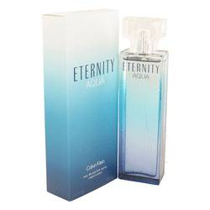

# 

***ELERNITY AQUA***

## *Description:*

Eternity Aqua by Calvin Klein Perfume. Exuding a pleasant aquatic bouquet, the eponymous Eternity Aqua for women wears perfectly from day to night. Pink lady apple and fresh cucumber notes open the stage for the main floral accents of white peony and magnolia. Dry, woody cedar undertones add a nostalgic note to an otherwise fresh and energizing mix. Launched in 2010 by Calvin Klein, the fragrance is soft and easy to wear, well-suited for hot summer months and subtle enough for everyday wear.